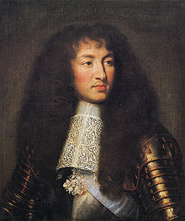

King Louis XIV of Versailles died on September 1st, 1715. He was 76 years old, only 4 days short of 77. Born on September 5th, 1638, he was the son of the late Louis XIII and his mother Anne D’Autriche. Some may know him better as the “Sun King”. Spending most of his life in France, he grew up around many notables and aristocrats. Because of this, he learned of military strategies and politics at a very early age. He took the throne at the age of four and was raised by Cardinal Mazarin who also took care of the governmental issues that arose while the young Louis was growing up. Mazarin helped with a dual setup until his death in 1661. This is when King Louis XIV took supreme rule and began the most famous absolutist rule in the history of Europe at the age of 23. Louis had a very successful reign including setting up absolutism in France and the court life in Versailles.
He was preceded in death by his father, Louis XIII, his son, Philip V, and his other son, Charles. He is survived by his five-year-old great-grandson Louis, Duke of Anjou, who has now inherited the French throne.
He died of gangrene and his body is being put to rest on his 77th birthday in Saint-Denis Basilica, outside of Paris.
On his deathbed, Louis advised his heir "Do not follow the bad example which I have set you; I have often undertaken war too lightly and have sustained it for vanity. Do not imitate me, but be a peaceful prince, and may you apply yourself principally to the alleviation of the burdens of your subjects".
Editor Kayla Percic

